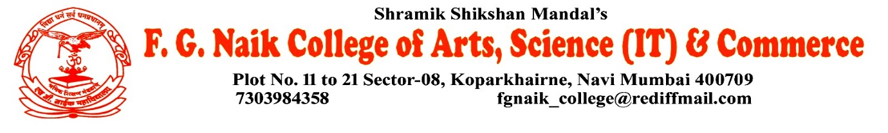

NSS UNIT
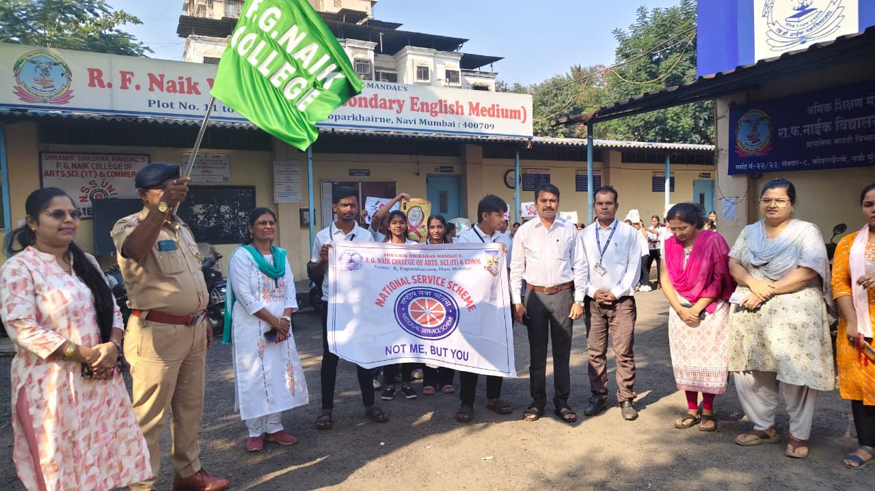
HIV/AIDS AWARENESS RALLY

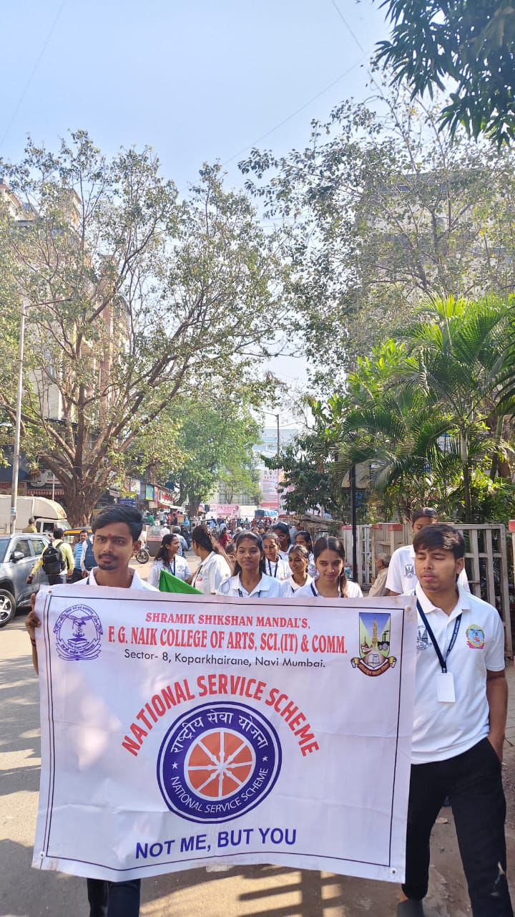
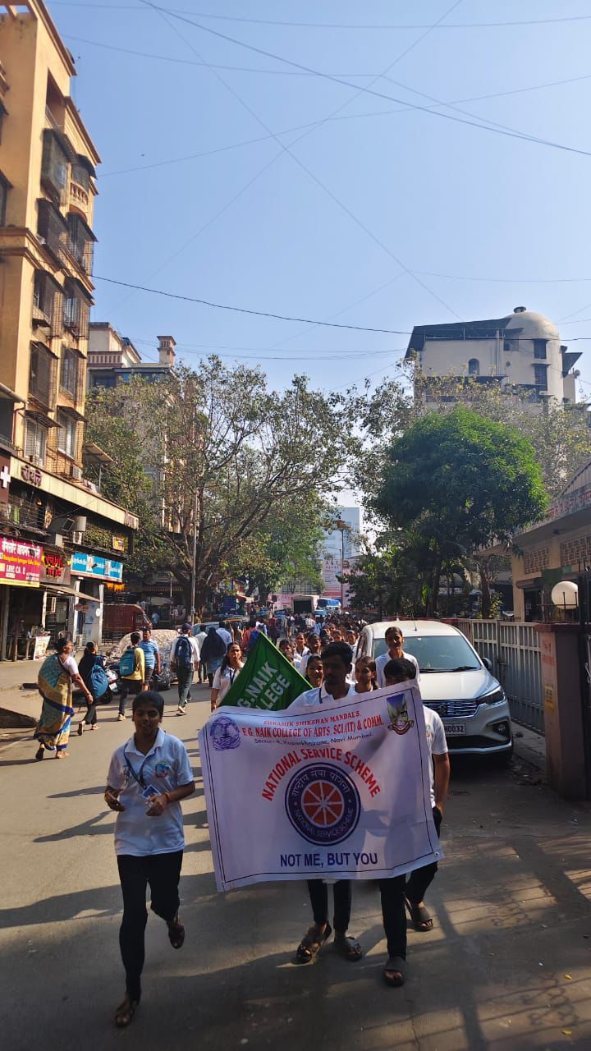

OBJECTIVE OF PROGRAM: To spread awareness about HIV/AIDS among the public, promote correct information regarding prevention, and encourage a stigma-free and responsible attitude towards people living with HIV/AIDS.
DATE: 01/12/2025
LOCATION: F.G Naik College
PARTICIPATING STAFF: All the NSS volunteers, teaching and the non-teaching staff of the college.
NUMBER OF VOLUNTEERS PARTICIPATING: 24
The NSS Unit organized an HIV/AIDS Awareness Rally to educate the community about HIV/AIDS and its prevention. The rally aimed to convey messages related to safe practices, early testing, and the importance of compassion and support for affected individuals.
The volunteers participated actively by holding placards and spreading awareness through slogans and messages. The rally successfully attracted public attention and helped in promoting awareness and social responsibility regarding HIV/AIDS.
PROGRAM DETAILS: The program commenced with a brief orientation, explaining the purpose and significance of the rally.
The NSS Unit successfully conducted the HIV/AIDS Awareness Rally, reinforcing the importance of awareness, prevention, and empathy in combating HIV/AIDS.

NSS IQAC
PROGRAM OFFICER CO-ORRDINATOR I/C PRINCIPAL

